**EXPERIMENT-1**

**Aim:**

Create a simple cloud software application and provide it as a service using any Cloud Service Provider to demonstrate Software as a Service (SaaS).

**PROCEDURE**

1. **Login to Zoho Creator**
   * Go to https://www.zoho.com/creator.
   * Sign in with a Zoho account (create one if not available).
2. **Create a New Application**
   * Click **Create Application**.
   * Choose **“Create from Scratch”**.
   * Give a name, e.g., *“Movie Ticket”*.
3. **Design the Form**
   * Add fields such as:
     + **Name** (Single Line)
     + **Phone Number** (Number)
     + **Date** (Date)
     + **Email** (Email field)
     + **Seat no** (Number)
4. **Add a Report View**
   * Select **Table View** to display submitted records.
   * Optionally add filters/sorting for easier usage.
5. **Test the Application**
   * Open the application link generated by Zoho Creator.
   * Enter sample student records and submit.
6. **Share and Access as SaaS**
   * Share the application link with other users.
   * Users can directly use the software via their browser without installation → demonstrating SaaS.

**OUTPUT:**

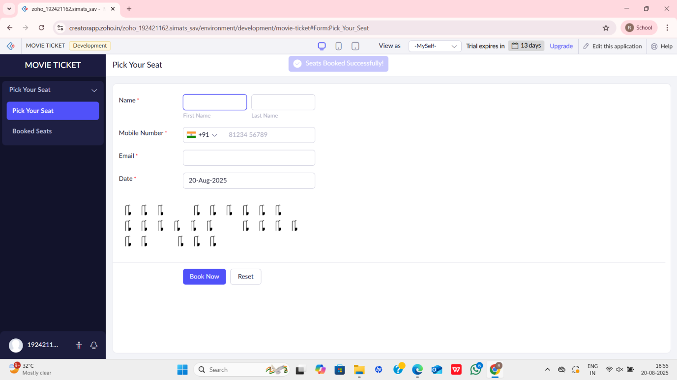

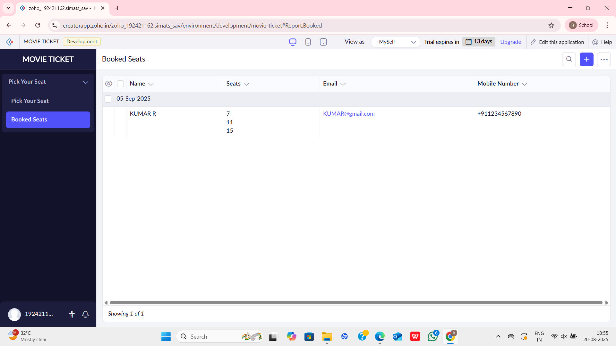

**RESULT**

A simple Student Record Manager application was successfully created using Zoho Creator. The application can be accessed and used via a web browser by multiple users without installation, thus proving the concept of Software as a Service (SaaS).